A Project Report

On

**QuadCopter Navigation**

BY

**Saksham Subhash Yadav**

**2020A8PS2156H**

Under the supervision of

**Dr.Abhishek Sarkar**

**SUBMITTED IN PARTIAL FULLFILLMENT OF THE REQUIREMENTS OF**

**ME F366:LABORATORY PROJECT**



**BIRLA INSTITUTE OF TECHNOLOGY AND SCIENCE PILANI (RAJASTHAN)**

**HYDERABAD CAMPUS**

**(NOVEMBER 2022)**

# ACKNOWLEDGMENTS

I appreciate the faith shown in me by the department of Mechanical Engineering to give me the opportunity to me work on this project which involves working on a QuadCopter along with a Pixhawk flight controller and a Raspberry Pi.  
I would like to thank Dr Abhishek Sarkar for allowing me to work on this project and allowing me to work on this project in accordance with my schedule by allowing me to work with the components after lab hours.  
I am also grateful to Dr Abhishek Sarkar and George Yuvaraj sir, for their guidance and help and for providing alternate solutions to the problems faced during the project work.

Lastly, I would like to thank my batch mates who helped me in formally, Bhavya Jain, Kalash Paripurnam, Pushkar Sapre and Abhiram Ravi who all helped me while debugging and flying the drone.



**Birla Institute of Technology and Science-Pilani,**

**Hyderabad Campus**

# Certificate

This is to certify that the project report entitled “**QuadCopter Navigation”,** submitted by Saksham Subhash Yadav (ID No. 2020A8PS2156H), partially fulfills the requirements of the course ME F366, Laboratory Project, embodies the work done by him under my supervision and guidance.

**Date: 7th November,2022 (Dr.Abhishek Sarkar)**

BITS- Pilani, Hyderabad Campus

# ABSTRACT

Through this project, we intend to establish communication between drones or drones to the ground station, which serves as the backbone for the other work to be commenced on other subsystems,which is the first step needed to be explored before diving deeper into more niche subsystems of implementation based drone functionalities.Therefore, the major objective of the project is to first fly assembled drones and use motion planning to plan the trajectory of flight and collect sensor data at the ground station and lastly keep a record of the steps involved in assembling the drones, the errors faced while working on it, the solutions to those problems and the learnings so as to have a handout ready for anyone to refer to who works on Pixhawk based drones.

Towards the end of the semester, We intend to connect Raspberry Pi with Pixhawk and establish data communication between the ground Station and the drone along with the flight logs which could be used for further analysis.

# CONTENTS

**ACKNOWLEDGMENTS** **2**

**Certificate** **3**

**ABSTRACT** **4**

**CONTENTS** **5**

Components and their Specifications 10

Q450 Quadcopter Frame 10

Pixhawk 10

DJI 2212 920KV Brushless DC Motor 11

1045(10×4.5) SF Propellers Black 11

SimonK 30A BLDC ESC Electronic Speed Controller 12

Flysky Transmitter 12

GPS Module 13

Lipo Battery 13

Assembly 15

Step1:Soldering Wire Connections 15

Step2: Assembling the Frame 15

Step3:Mounting Motors 15

Step4:Mounting ESCs 15

Step5:Making Mock Connections 16

Step6:Labeling Motors 16

Step7:Placing the Flight Controller and the GPS module 17

Step8:Making Final Connections 17

Mission Planner 20

Installing Mission Planner 22

LED/Buzzer Meanings 23

Tone Identification 25

Safety Switch 26

LED meaning(LED on the Switch itself): 26

Buzzer (aka Tone Alarm) 27

Calibration and Testing 29

Radio Transmitter and Receiver Binding 29

Initial Parameter SetUp 29

Accelerometer and Compass Calibration: 30

Radio Calibration 31

ESC Calibration: 32

Flight Mode: 32

FailSafe 33

GeoFence 33

Parameter Setup 33

Logging 33

ArmCheck 33

Conclusion 34

## Components and their Specifications

### Q450 Quadcopter Frame

* Wheelbase: 450mm
* Material: Glass Fiber + Polyamide-Nylon
* Weight: 330 gm
* Motor Mounting Hole Dia.: 3 mm
* Arm Size: 220 x 40 (LxW) mm
* Landing Gear Material: ABS
* Landing Gear Height: 200 mm

### Pixhawk

|  |  |
| --- | --- |
| **Model** | PIX 2.4.8 32 Bit |
| **Input Voltage (V)** | 7V |
| **Firmware** | Mission Planner |
| **Sensors** | 3-Axis Gyrometer  Accelerometer  High-performance Barometer  Magnetometer |
| **Processor** | 32 bit STM32F427 Cortex M4 core with FPU  The 32-bit STM32F103 failsafe Co-processor |
| **Micro-SD Card Slot** | Yes |
| **Dimensions (mm) LxWxH** | 82 x 50 x 16 |
| **Weight (gm)** | 40 |

### DJI 2212 920KV Brushless DC Motor

* Motor KV: 920 RPM/V
* Motor Rotation: CCW for Silver Cap
* Motor Rotation: CW for Black Cap
* Thrust: Around 0.5 kg
* LiPO Batteries: 3S-4S
* Rated Voltage(V):7~12
* ESC: 30 A
* Shaft Diameter: 6 mm
* Dimensions(mm):28*28*46
* Weight: 60 g

### 1045(10×4.5) SF Propellers Black

* Length: 10″.
* Pitch: 4.5″.
* Weight: 14 gm.
* Shaft Diameter: 6 mm.
* Total length: 10 inch / 254 mm.

### 

### SimonK 30A BLDC ESC Electronic Speed Controller

* Model: SIMONK 30A.
* Constant Current: 30A (Max 40A < 10 sec).
* BEC: 5V 2A.
* Suitable Batteries: 2-3S LiPo.

### Flysky Transmitter

|  |  |
| --- | --- |
| No. of Channels | 6. |
| RF Range (GHz) | 2.40 ~ 2.48 |
| Bandwidth (kHz) | 500 |
| RF Power (dBm) | ≤20 |
| Sensitivity | 1024 |
| Low Voltage Warning (V) | ≤ 4.2 |
| Power | 6V (4 x 1.5AA Not Included) |
| Display mode | Transflective STN positive type, 128*64 dot-matrix VA73*39mm, white backlight |

### 

### GPS Module

* Locate performance
* These are Pre-configured, Flashed with the correct settings, and tested. To make them Plug and Play.
* Super Bright LED
* Backplane with Standard Mk style mounting holes 45mm X 45mm
* 38400 bps (Default) Changed to 115200 bps!
* Output GGA, GSA, and RMC frames
* 1Hz (Default) Changed to 5Hz!
* Permanent Configuration Retention
* compass on board
* 6-pin connector for EZ connect to MEGA BLACK
* 4-pin connector for only GPS use
* 4-pin connector for compass only use
* Can use both four pins at once.

### Lipo Battery

|  |  |
| --- | --- |
| Model No. | ORANGE 5200 / 3S-40 |
| Capacity (mAh) | 5200 |
| Weight (gm) | 360 |
| Output Voltage (VDC) | 11.1 |
| Charge Rate (C) | 1 ~ 3 |
| Discharge Plug | XT-60 |
| Balance Plug | JST-XH |
| Length (mm) | 137 |
| Width (mm) | 44 |
| Height (mm) | 37 |
| Max. Burst Discharge (C) | 80C(416.0A) |
| Max. Charge Rate | 5 C |
| Max. Continuous Discharge | 40C(208.0A) |

### 

## Assembly

#### Step1:Soldering Wire Connections

Take the bottom frame with the printed circuit board and solder wires to connect to ESCs later, which would be used to power the motors.

#### Step2: Assembling the Frame

Now keep the PCB frame as the bottom plate, and attach it to four arms with two screws each. Now attach the other plate on top with four screws each. On one of the arms, attach the GPS stand mount which would be used to keep the GPS module a few inches above the frame level. Take care not to fully tighten the screws before placing all the screws in place. Once you have all the (2*4+4*4)=24 screws in place, tighten all of the screws to achieve tension in the frame. In case it is tough to attach four screws on each arm owing to the alignment issue of the screws and slots, three screws would be enough.

#### Step3:Mounting Motors

We have two different sets of motors, the one rotating in the clockwise direction and the other rotating in the counterclockwise direction. So we need to mount the motors to the outer edge of the arm on the slots provided with four screws each. Take into account that the motors rotating in the same direction are supposed to be mounted on diagonally opposite arms to cancel out torque which would topple the drone if both the motors on the same side of the drone rotate in the same direction.

#### Step4:Mounting ESCs

We can now attach the ESCs tightly on the arm's length with the side having two sets of three wires facing each of the motors with the aid of zip ties or insulation tapes. One set of three wires is supposed to be connected to the motors, while the three jumper wires are meant to be connected to the flight controller.

The lone set of two wires on the other side of the ESC is meant to be connected to the wires we soldered to the PCB on the lower plate of the frame earlier. Before attaching the ESC, check for the wires and if they are of the appropriate length to connect to the corresponding wires. For jumper wires we might need extra jumper wires to increase the length.

#### Step5:Making Mock Connections

Connect the ESCs to the motor, then the other set of wires to the soldered wire on the frame. After that, connect the jumper wires of the ESCs to pins on the side labelled as the MAIN OUT. The wiring colours on ESC are either orange, red and brown, or white, red and black corresponding to the signal, positive, and negative terminals. The top row of the Pixhawk slots is for the signal wire, and the bottom row is for the ground wire from the ESC. We

#### Step6:Labeling Motors

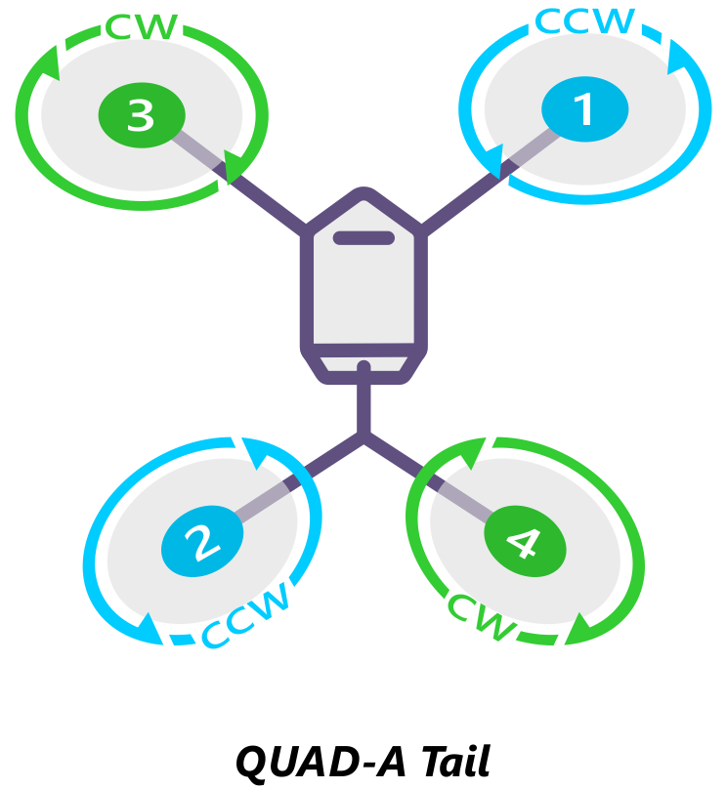

Now label the motor as shown in the figure and connect the wire from the esc in the same order from slot 1 to 4 of the MAIN OUT of the Pixhawk.

#### Step7:Placing the Flight Controller and the GPS module

Attach the flight controller using double-sided tape on a shock absorber, which is attached to the frame and attach the GPS module on top of the stand.

#### Step8:Making Final Connections

Connect the ESC as labelled to the MAIN OUT of the flight controller. Connect the PPM slot of the receiver to the RC slots of the flight controller as shown in the figure.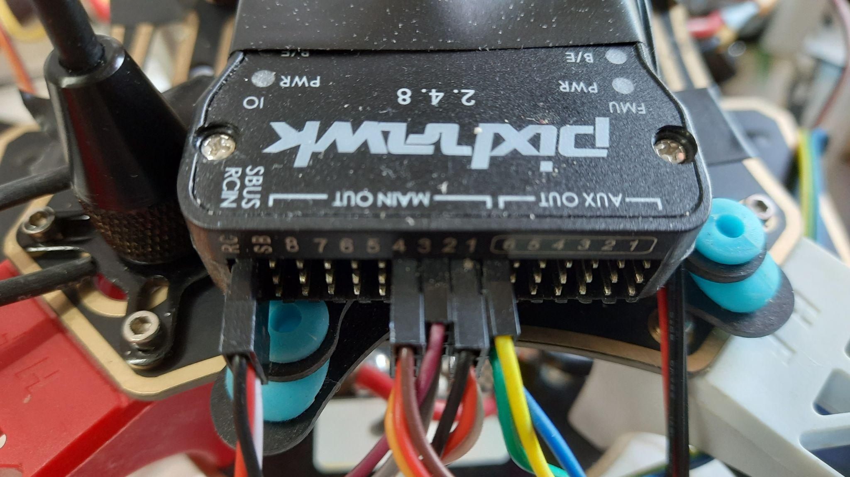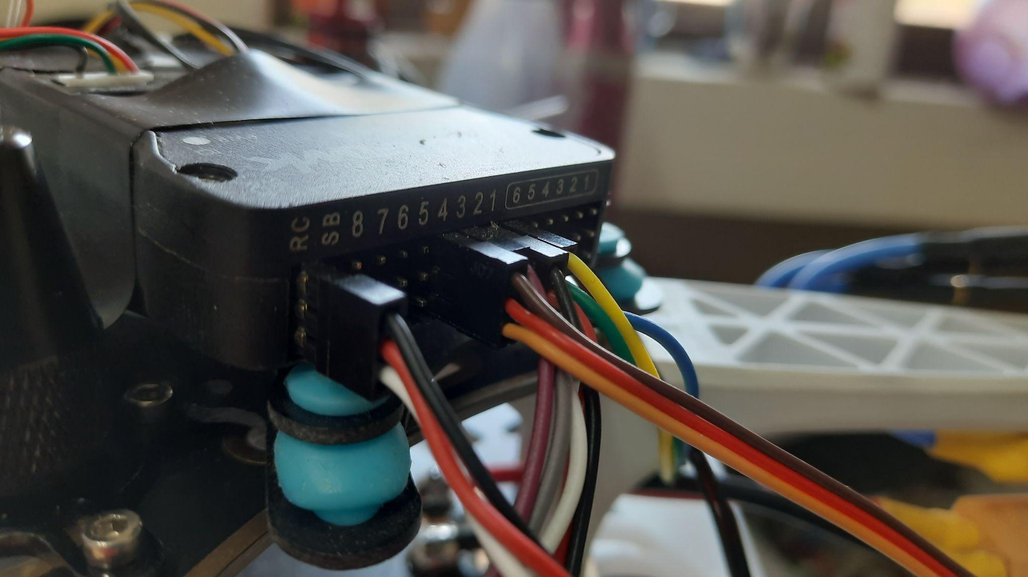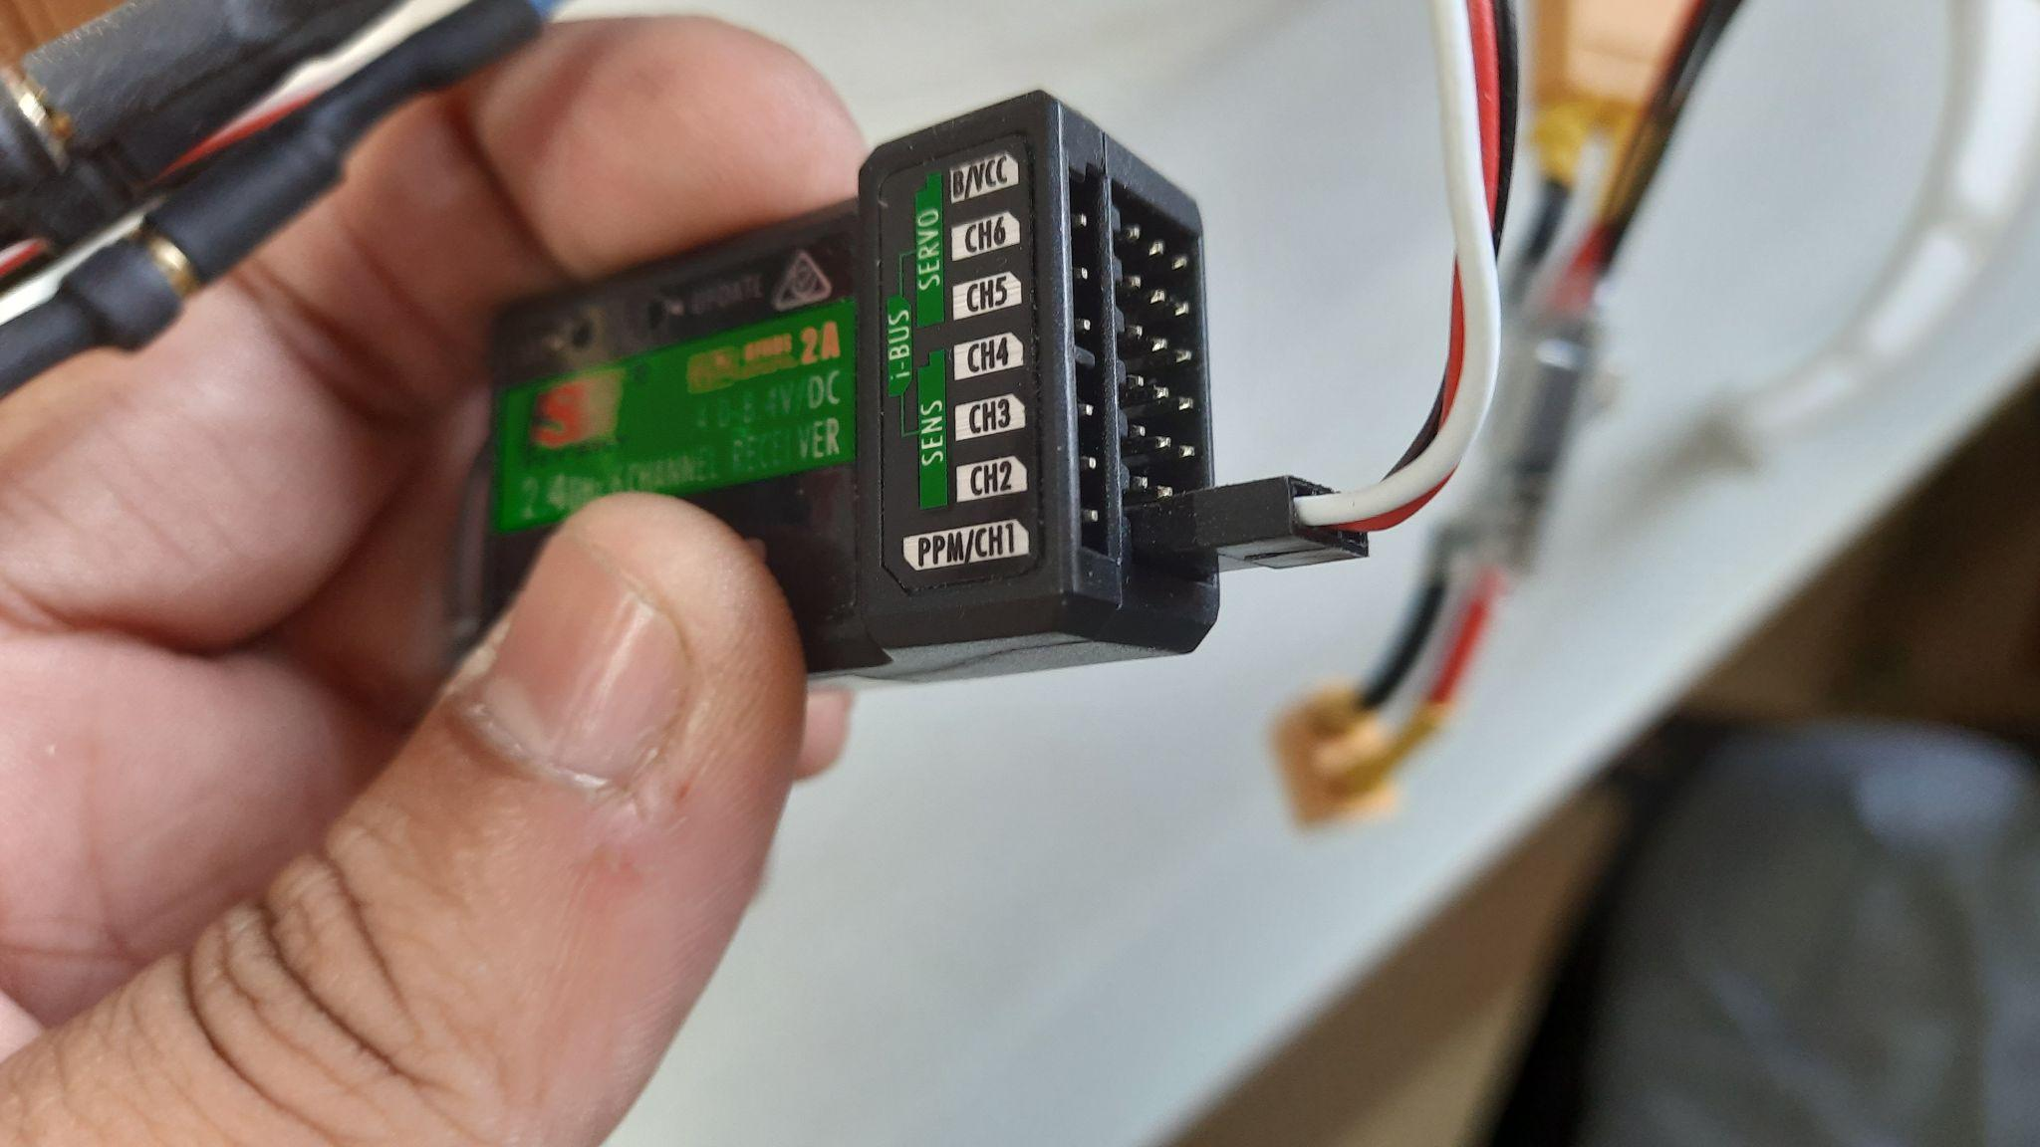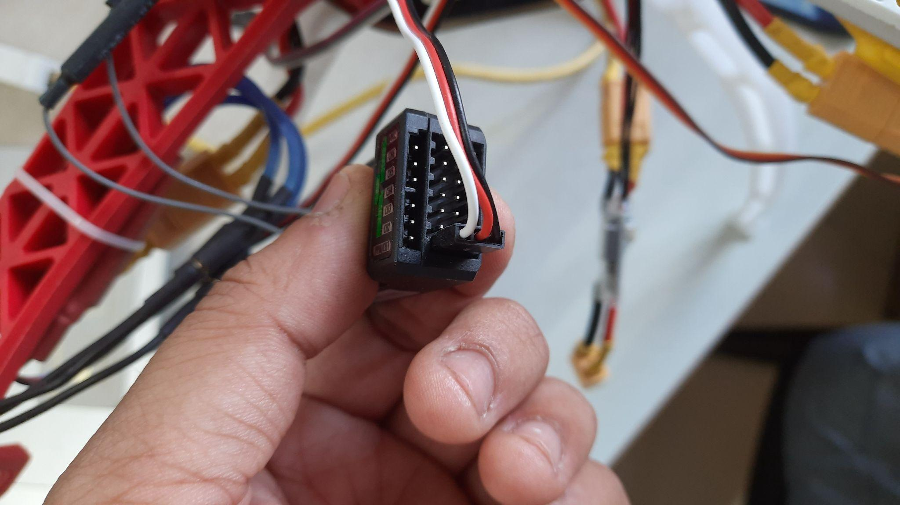

Connect the switch and buzzer as shown in the figure below.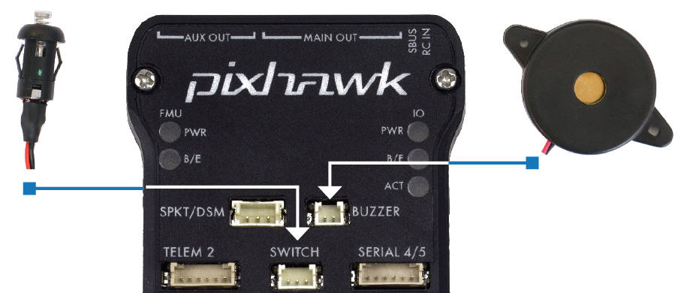

Connect the three wired pins of the GPS module to the i2c Socket of the pixhawk and the other pin to the GPS slot.

Lastly, connect the wire from the voltage supply to the power supply slot on the flight controller.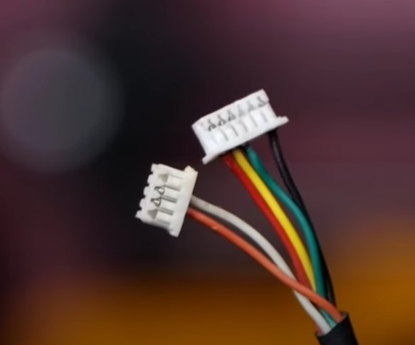

**Step9:**

Now that the whole assembly is done, we need to be aware of the few alerting mechanisms of the Pixhawk to prevent any harm to the drone. After that, we can calibrate all the sensors and be ready to fly them. We also need to be aware of the Mission Planner software we would use for calibration, mission planning and finding flight log files for further analysis.

## 

## Mission Planner

Mission Planner is one of many control Station software available in the market. It specialises in ardupilot based flight controllers for Plane, Copter and Rover. The following screenshots are from the Mission Planner Software (V1.3.76).

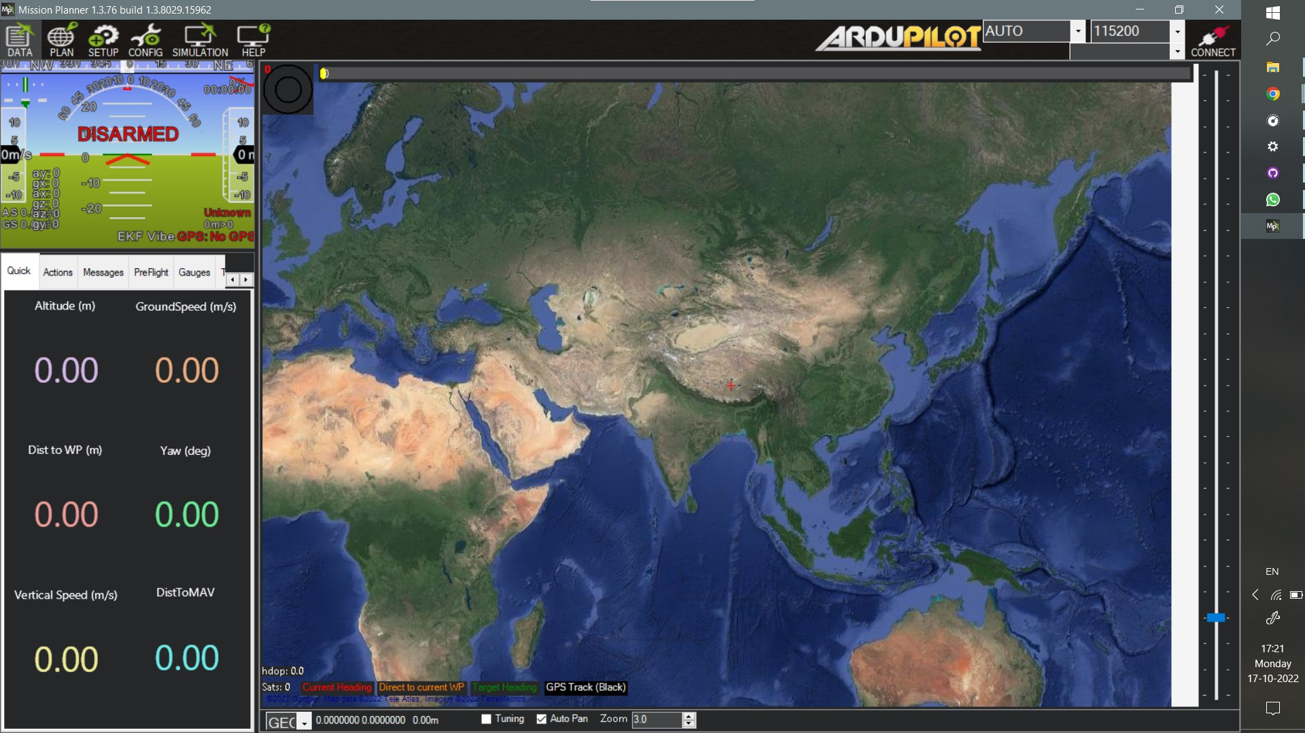

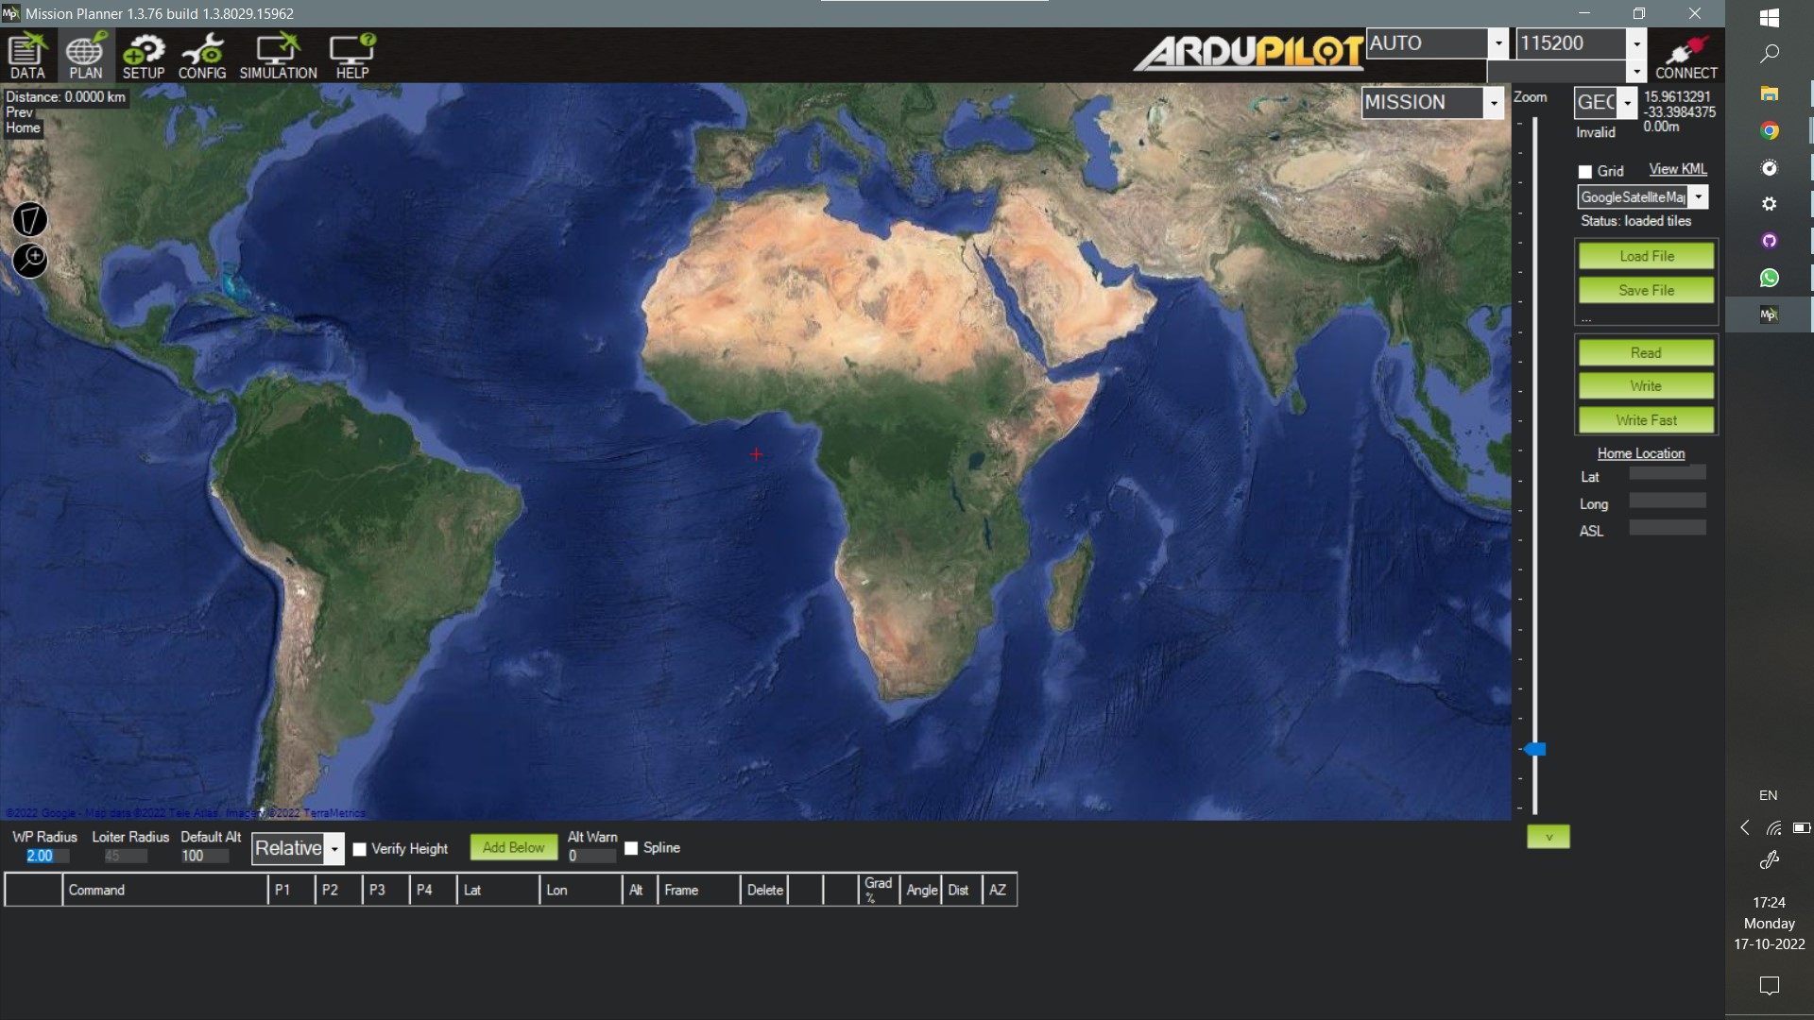

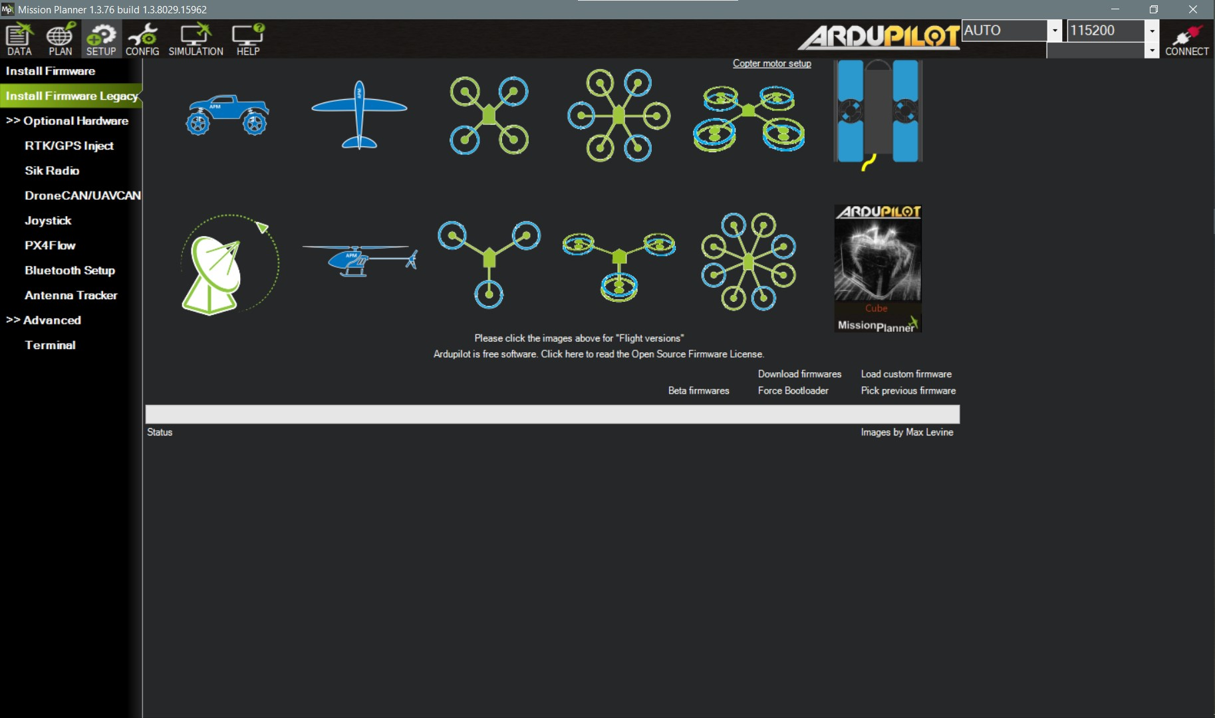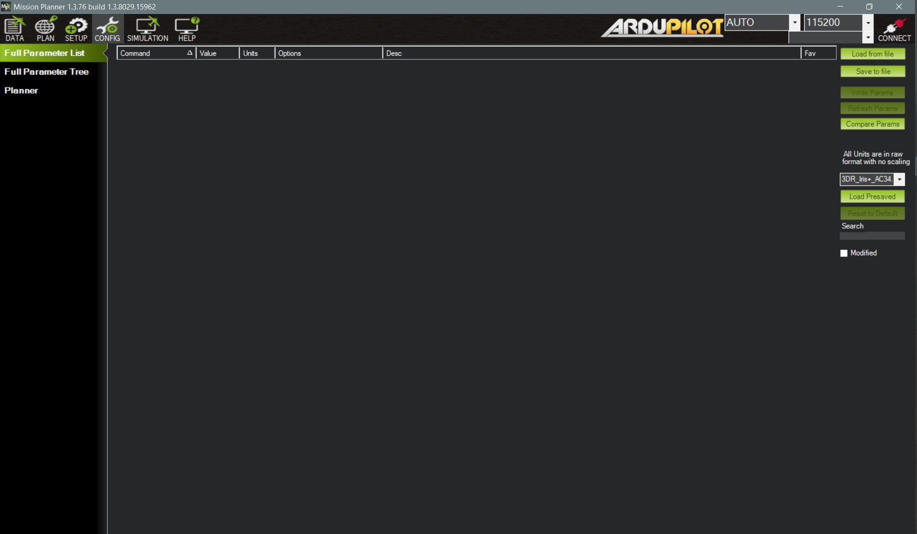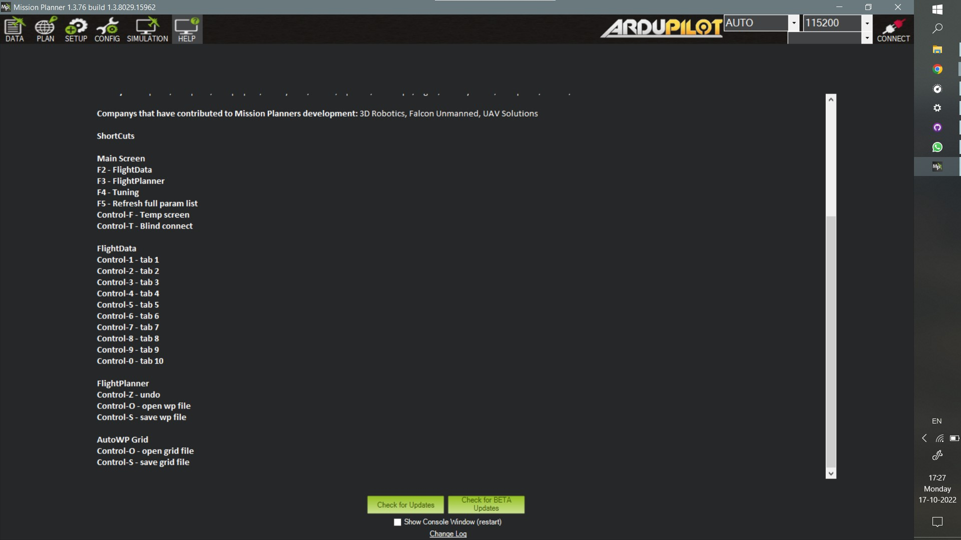

### Installing Mission Planner

Mission Planner was initially designed for Windows, but a beta version is available for Android, and a beta version for Linux is available too. Double-click the downloaded .msi file to run the installer from the [Ardupilot website](https://ardupilot.org/planner/docs/mission-planner-installation.html).

Follow the instructions to complete the setup process. The installation utility will automatically install any necessary software drivers. If you receive the warning pictured below, select Install this driver software to continue.  
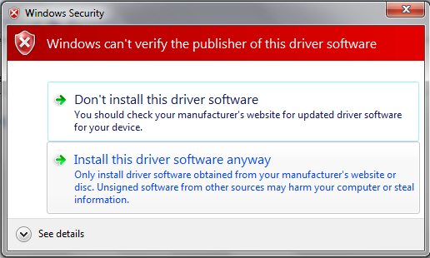

## LED/Buzzer Meanings

**Flashing blue and red:** Initializing gyroscopes. Hold the vehicle still and level while it initialises the sensors.

**Flashing blue:** Disarmed, no GPS lock found. Autopilot, loiter, and return-to-launch modes require GPS lock.

**Flashing green:** Disarmed (ready to arm), GPS lock acquired. Quick double tone when disarming from the armed state.

**Fast Flashing green:** Same as above, but GPS is using SBAS (so it should have a better position estimate).

**Solid blue:** Armed with no GPS lock.

**Solid green with a single long tone at the time of arming:** Armed, GPS lock acquired. Ready to fly!

**Double flashing yellow:** Failing pre-arm checks (system refuses to arm).

**Single Flashing yellow:** Radio failsafe activated

**Flashing yellow - with sharp beeping tone:** Battery failsafe activated

**Flashing yellow and blue - with high-high-high-low tone sequence (dah-dah-dah-doh):** GPS glitch or GPS failsafe activated

**Flashing red and yellow - with rising tone:** EKF or Inertial Nav failure

**Flashing Red, Blue and Green:** Copter ESC Calibration mode entered.

|  |  |  |
| --- | --- | --- |
| **State** | **LED** | **Description** |
| Initializing (calibrating gyros) | rgbinit | Blinking Red & Blue. |
| Save Trim or ESC Calibration | rgbsavetrim | Blue-Green-Red |
| Leak failsafe | rgbleakfs | Slow Yellow and White |
| EKF failsafe | rgbekffs | Slow Red and Yellow |
| GPS glitch | rgbgpsglitch | Slow Blue and Yellow |
| Radio/GCS/Batt failsafe | rgbcontrolfs | Fast Yellow and White |
| ARMED:3Dfix | rgbarmed | Solid Green |
| ARMED: No valid GPS fix | rgbarmednogps | Solid Blue |
| DISARMED:pre-arm checks failing | rgbprearm | Blinking Yellow and White |
| DISARMED: good DGPS fix | rgbready1 | Fast Blinking Green |
| DISARMED: good GPS fix | rgbready2 | Slow Blinking Green |
| DISARMED: bad GPS fix | rgbbadgps | Blinking Blue |

## Tone Identification

The tone alarm is used for indication of various states of the flight controller, ranging from EKF failure, startup failure, new firmware found, or no sd card found, indicating whether the drone is armed or not, whether the battery is low, is the GPS connected or not, with many more.

The audio files renamed as the state they stand for, can be found on the following [github](https://github.com/sakshamssy/quadcopter_navigation/tree/main/Buzzer%20Sound-Alarm%20Tunes) repository.

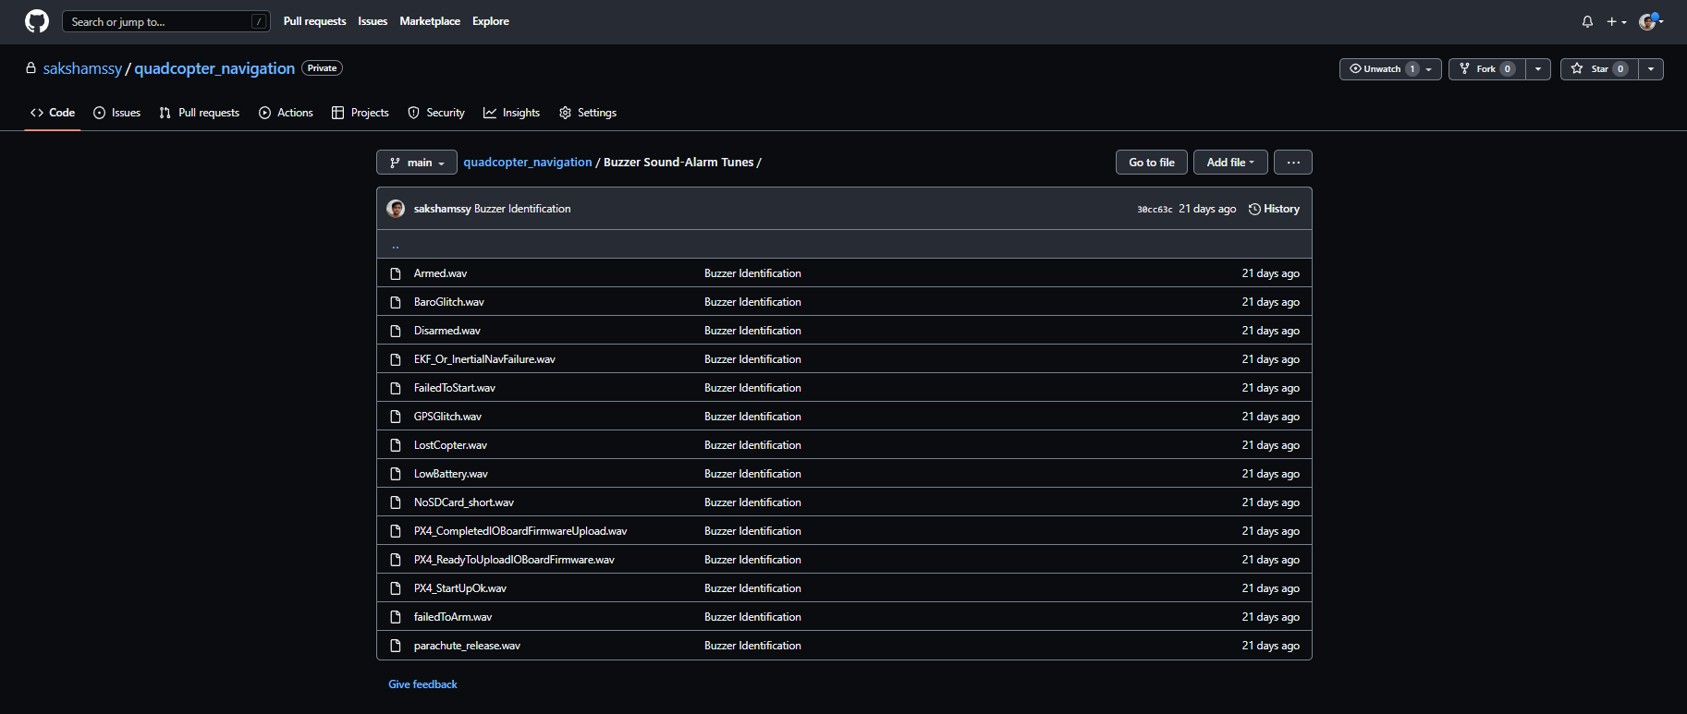

## 

## Safety Switch

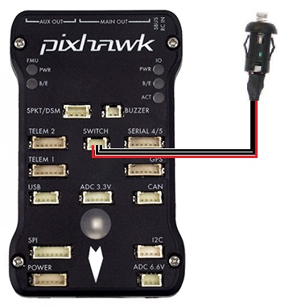

A safety switch can enable/disable the outputs of motors and servos.

### LED meaning(LED on the Switch itself):

* **Constant blinking** - the system is initialising
* **Intermittent blinking** - the system is ready. Press the safety switch to enable output to the motors.
* **Solid** - safety switch has been pressed, and motors and servos can move once the vehicle is armed.

**Using the Safety Switch to force I/O board firmware update**

If the safety switch is held down for the first few seconds after a Pixhawk is powered up, the I/O firmware is reloaded. This usually is not required, but in some rare cases is required after a firmware upload if you hear the “Start up Failed” sound after startup (see [Sounds wiki page](https://ardupilot.org/copter/docs/common-sounds-pixhawkpx4.html#common-sounds-pixhawkpx4)).

### Buzzer (aka Tone Alarm)

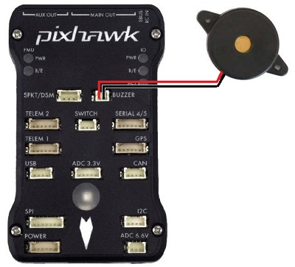

If an active buzzer is used, it can indicate the following:

|  |  |
| --- | --- |
| **Status** | **Pattern** |
| Arming | 3-sec long Beep |
| Arming Failed | Single Beep |
| Disarmed | Single Beep |
| Battery Failsafe | Single Beep repeating every 3 seconds |
| EKF Failure | Beeeep-Beeep-Beep-Beep |
| Lost Vehicle | Beep-Beep repeating every 3 sec |

**Mounting the buzzer:**

The sound from the buzzer can impact the accelerometers if placed too close to the autopilot which can lead to poor altitude hold performance when the buzzer is activated. The buzzer should ideally be mounted at least 5cm away from the autopilot, and the speaker (i.e. the open hole) should not be pointing directly at the autopilot.

## Calibration and Testing

### Radio Transmitter and Receiver Binding

We first need to bind the transmitter and the receiver to ensure that they transmit and receive data from each other. To do this, we connect the first and the third pin of the B/VCC slot of the receiver from the bottom and power the receiver using any other channel. You would notice a blinking red LED signifying it is in binding mode. Switch on the transmitter by pressing the binding key while switching it on. Now on switching on the transmitter with the bind key pressed down, you would notice that the LED stops blinking, signifying that the transmitter and receiver are now bound to each other.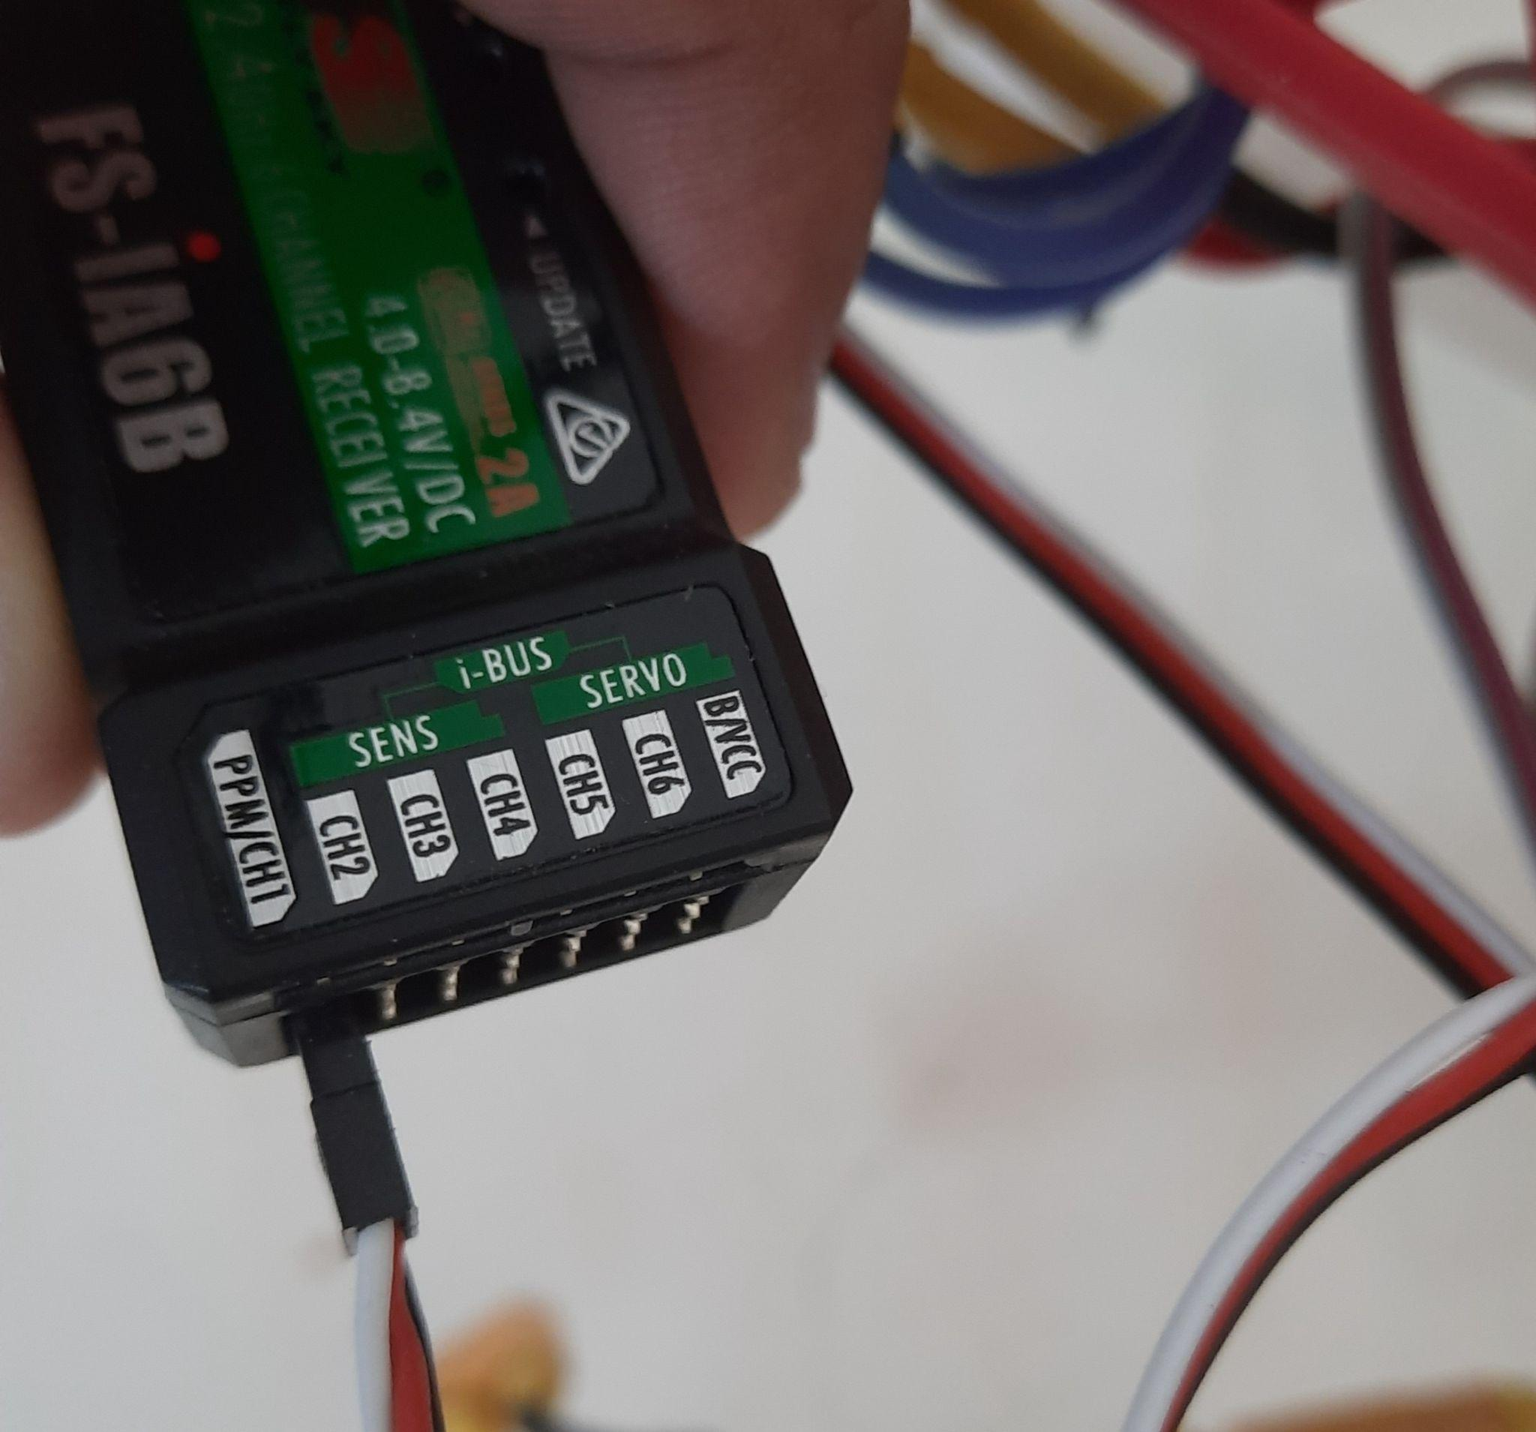

### Initial Parameter SetUp

Now connects your computer's flight controller through a MicroUSB cable to Mission Planner Software using the baud rate of 115200. After connecting, browse to the setup section of the software and choose the frame type as “X”, and change the initial parameters if required(if your battery has three cells and it is shown as four cells here, then make the appropriate change) or let it remain unchanged to its default value.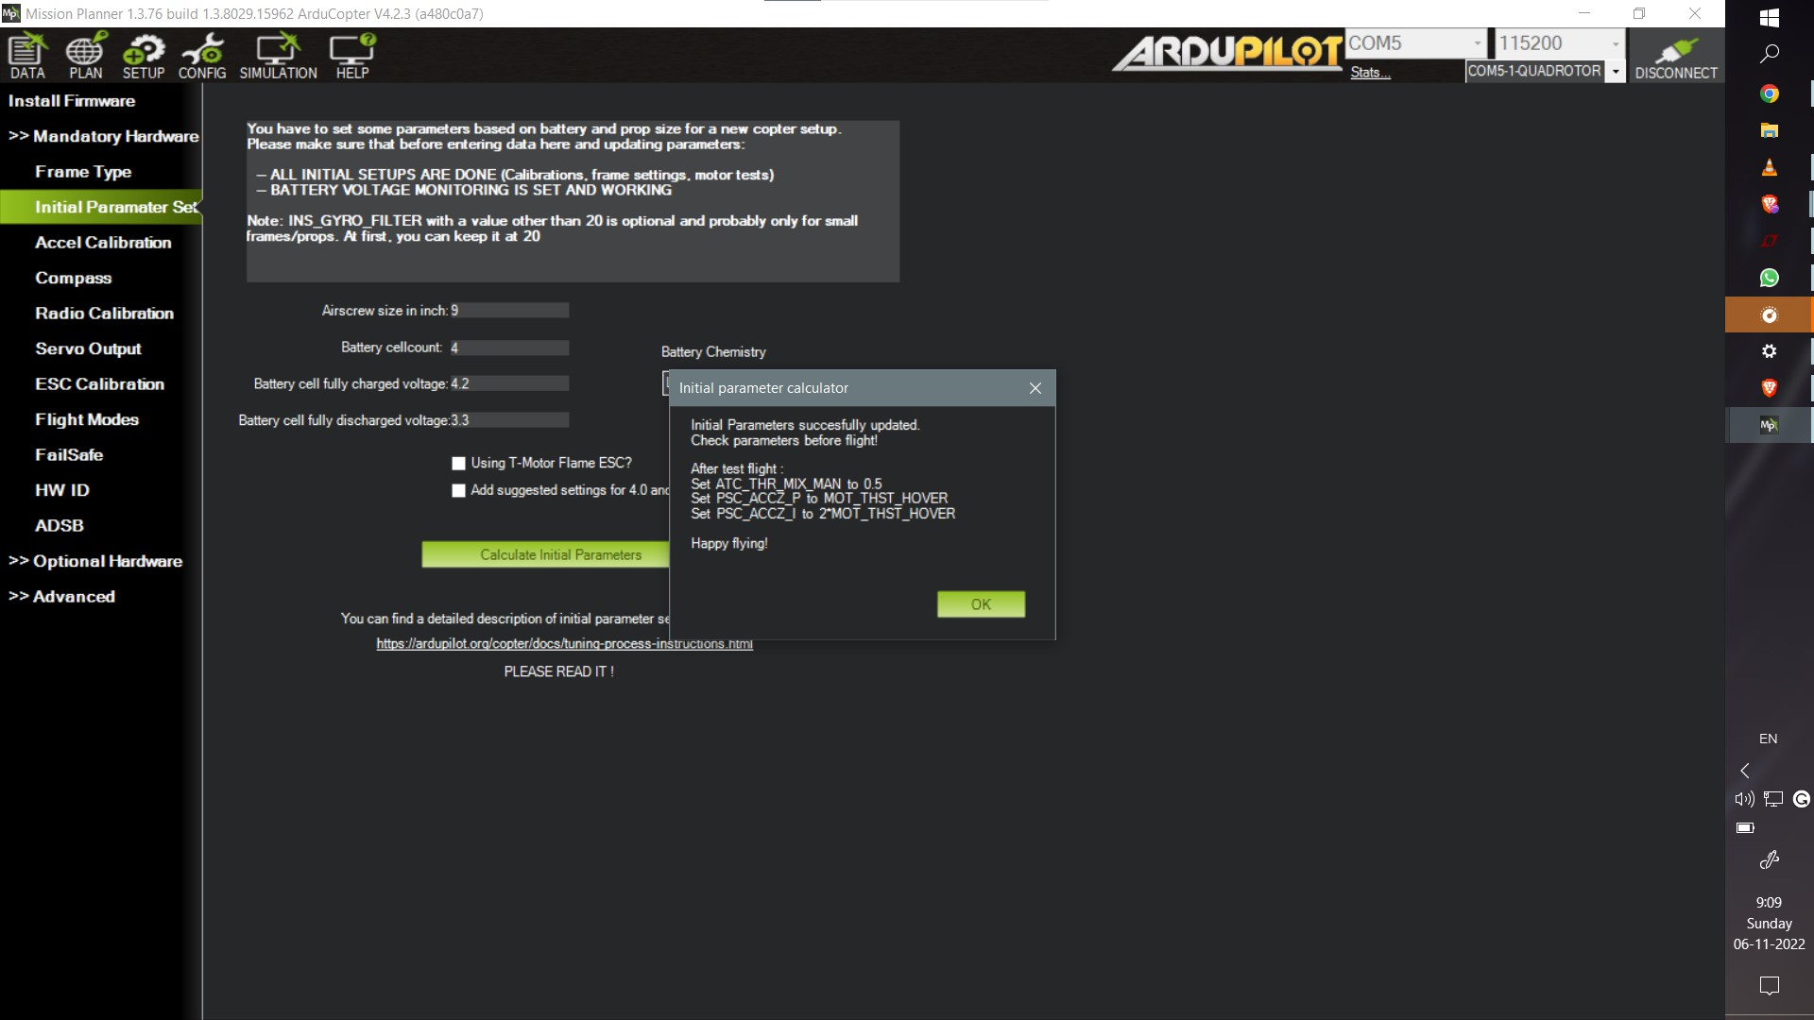

### Accelerometer and Compass Calibration:

Calibrate your accelerometer and the compass by following the commands provided by the software.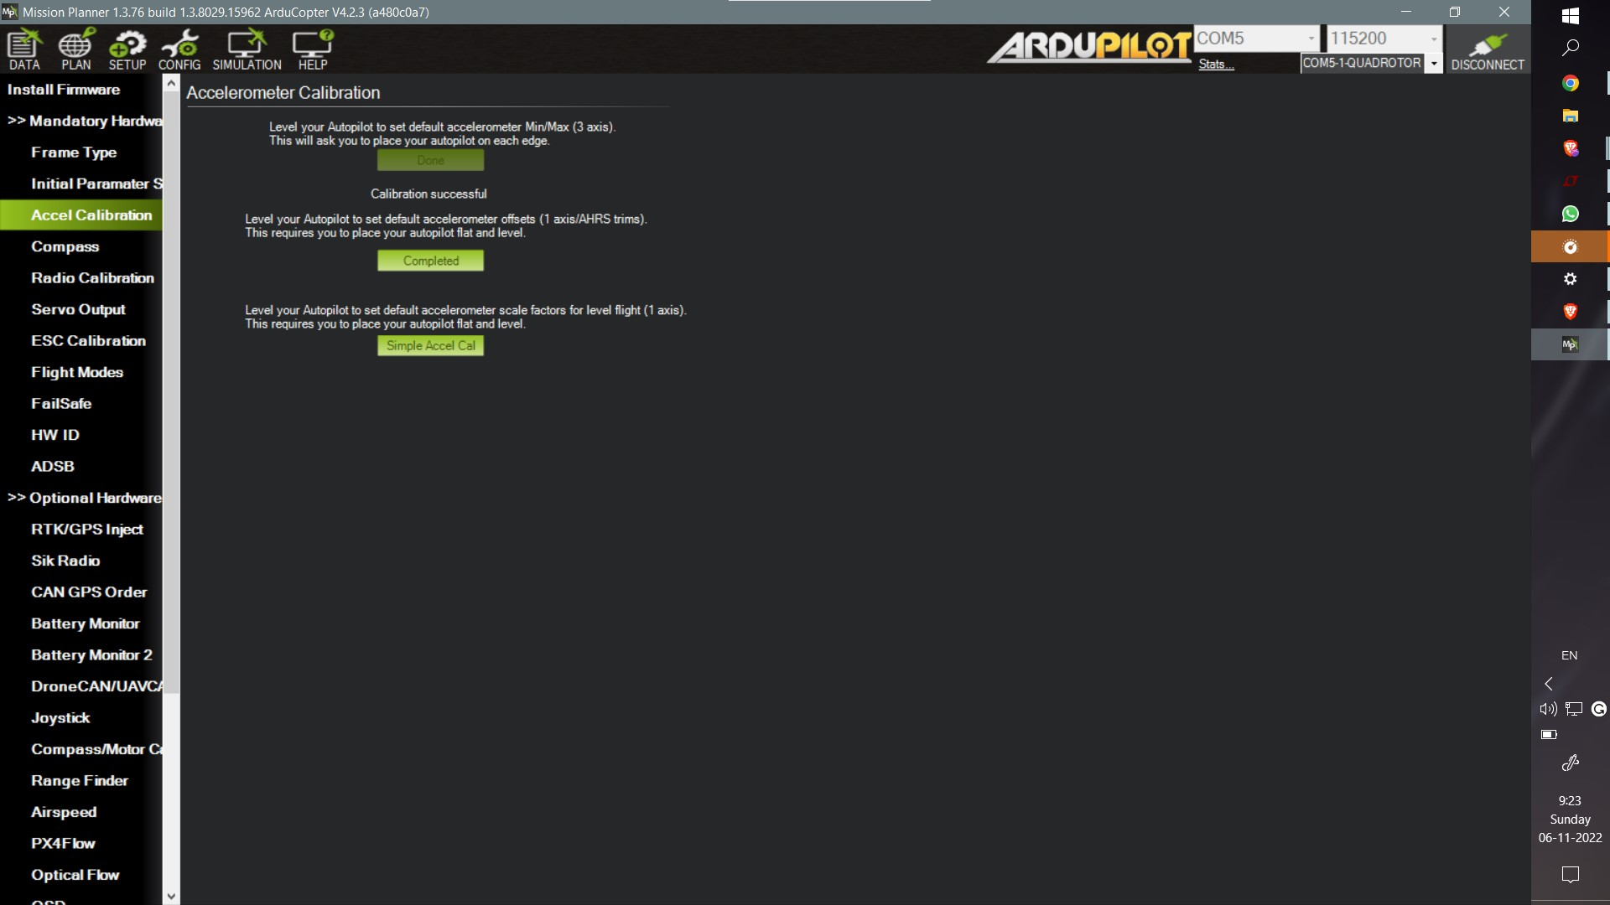

### Radio Calibration

After calibrating the accelerometer and compass, calibrate the radio as follows: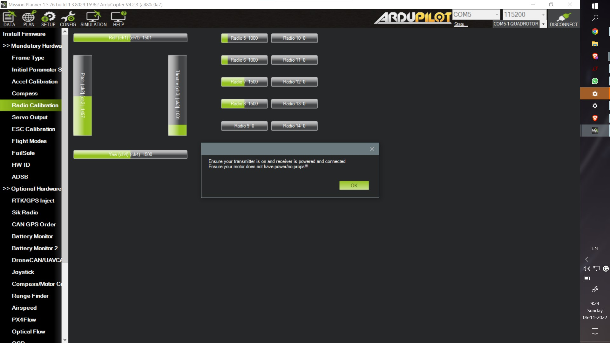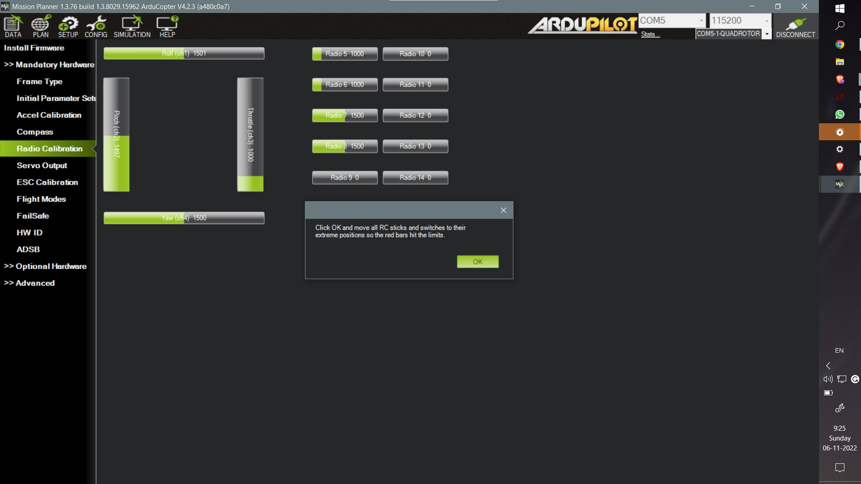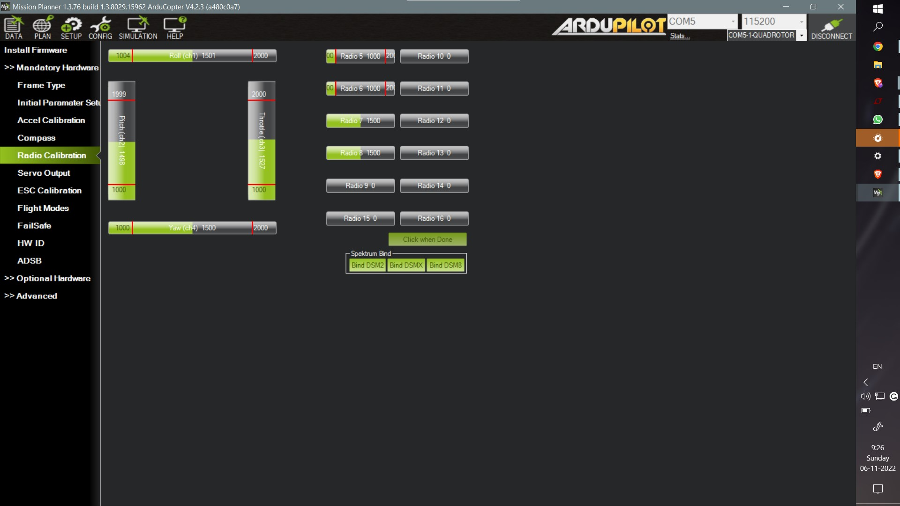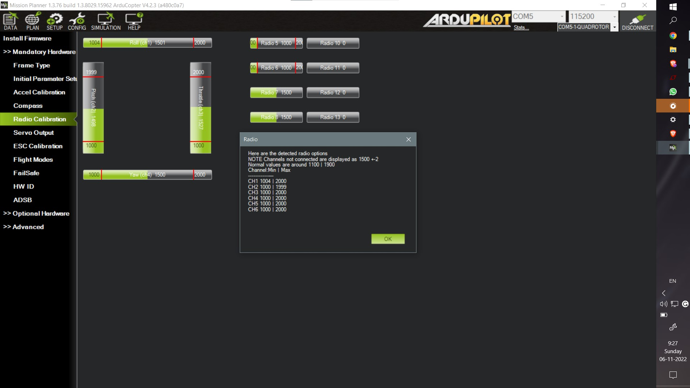

### ESC Calibration:

Similarly follow the steps given by the software for ESC calibration.

### Flight Mode:

You use 4 channel of data transmission for transmitting roll,yaw,pitch and throttle value.Therefore ,you can use the fifth channel of data for selecting the flight mode you want to fly the drone in.These additional assistance in flying is useful for variety of use cases.For example **Loiter mode**,which holds the drone at a place and keeps it hovering at the same place if the throttle is kept at 50%, can be used for taking still footages.

**Altitude hold** is a similar mode in which we can move the drone in a XY plane with the altitude kept constant when throttle is kept at 50%.**RTL(Return To LaunchPad)** Mode uses the GPS data and returns to the point fom where it was launched.

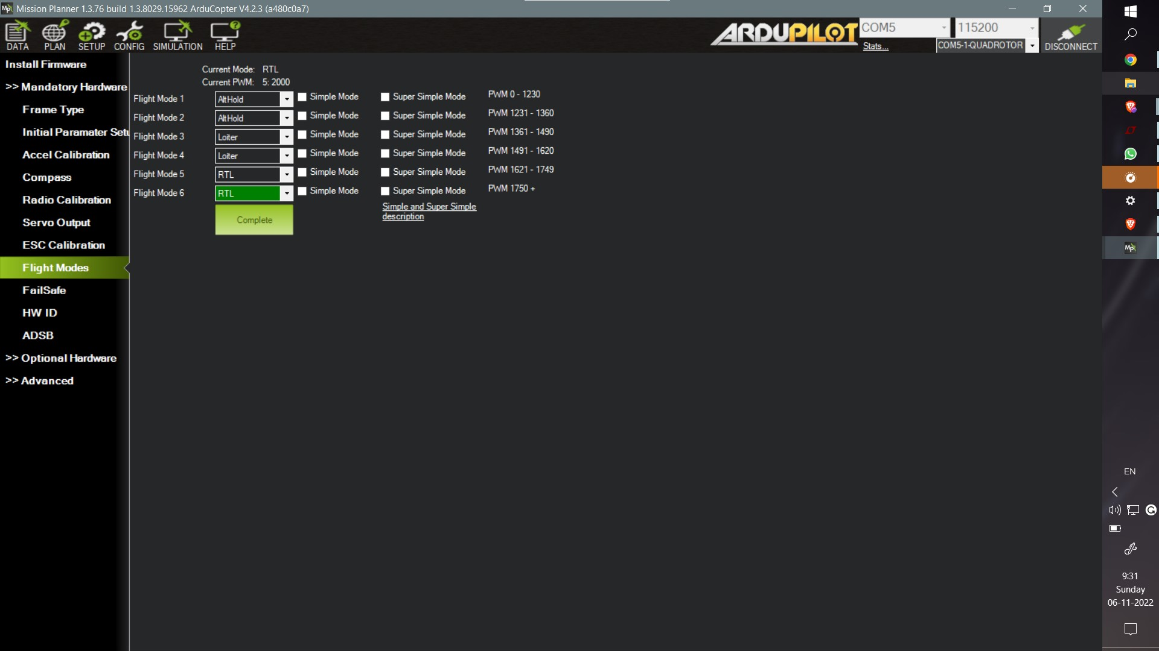

### FailSafe

Failsafe mode is a precautionary step that ensures safekeeping of the quadcopter from system failures such as low battery,transmission signal loss etc. So along with the geofence, the fail safe mechanism can make the drone either land or return to launchpad(as set by parameters), if the battery is below certain voltage or the drone has flown away from the designated geofence.

### GeoFence

Geofence is like a virtual perimeter for the real geographic area which we can assign the drone to be confined in or out of.In the Mission Planner Software, you can create polygons to mark area as inclusion area where the drone is supposed to fly or exclusion area where the drone is not supposed to delve into. 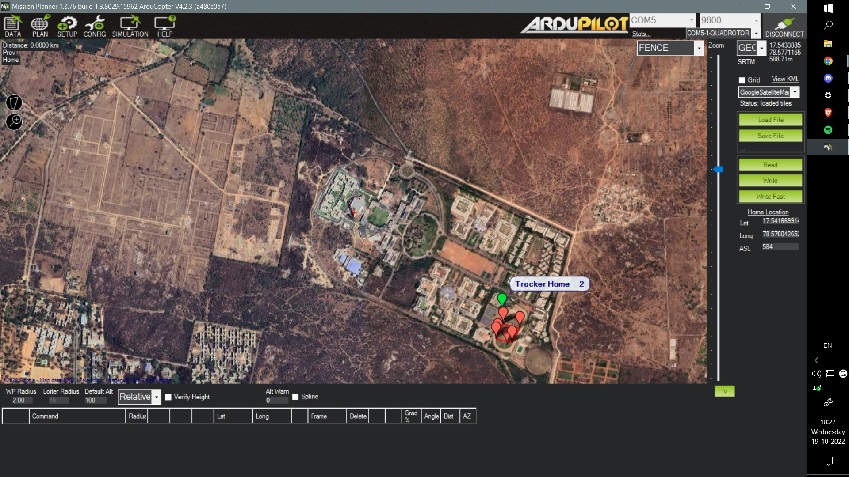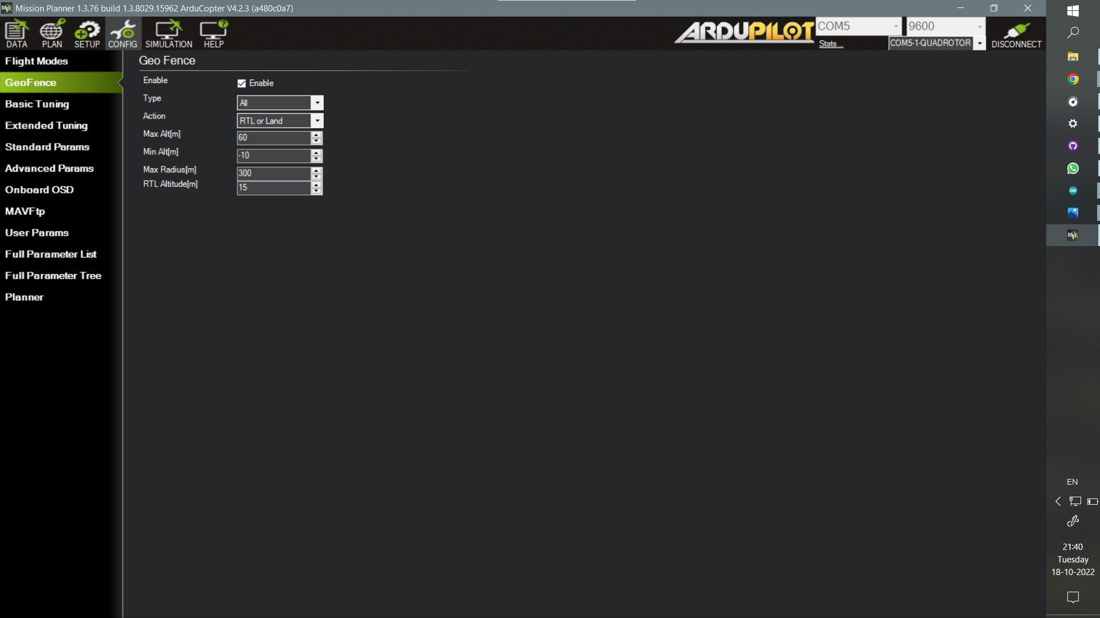

## 

## 

## 

## 

## Parameter Setup

There exist a number of parameters that control each and every parameter of the flying drone, from roll, pitch,yaw adjustments to whether or not we want safety checks before flying or do we want telemetry flight logs or not. We customize the working of the drone whichever way we want by changing these parameters.The whole list of parameters can be found in the config menu in a descriptive way in order to help us choose correct values of parameters we want to put in.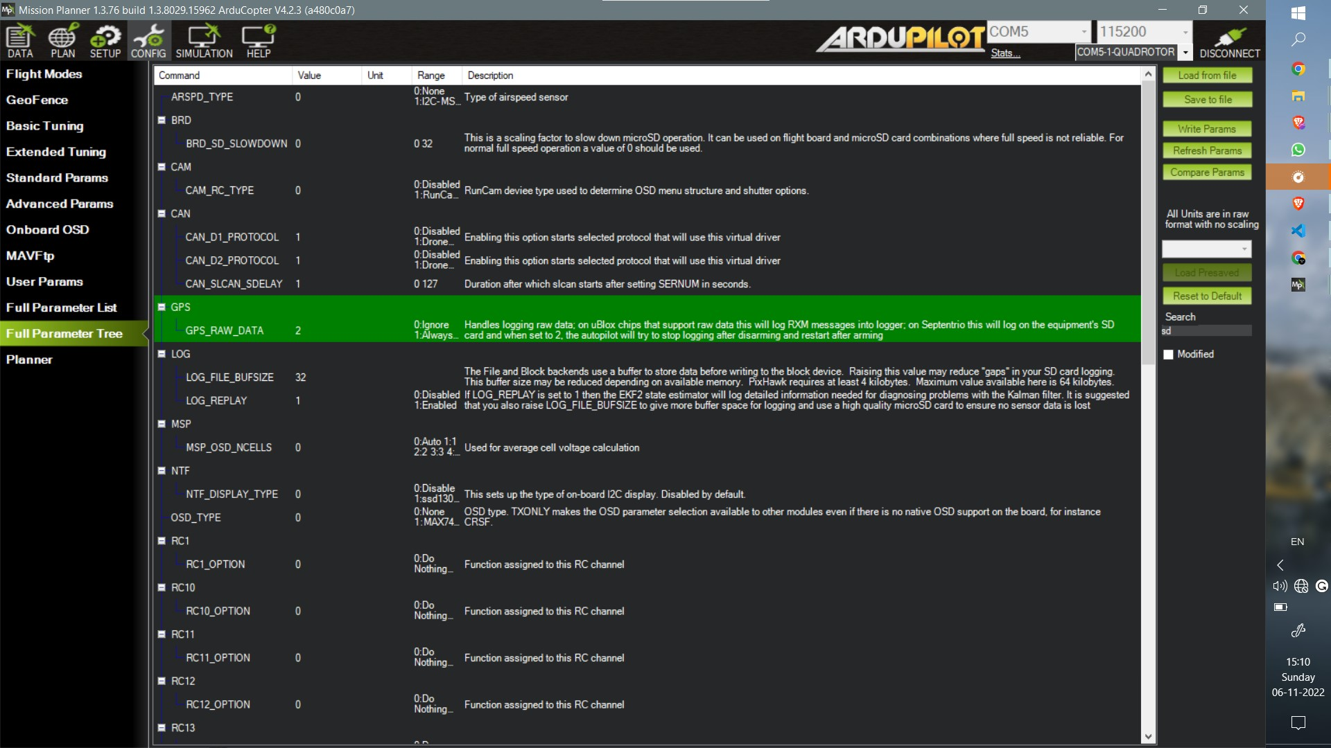

### Logging

The after flight log data comprising of the on flight data of accelerometer, compass, GPS, telemetry commands and many other sensor data can be of vital for after flight analysis for optimization.This data can be collected and stored in the sd card in pixhawk by changing a few parameters as shown in the picture.The exact parameters list used can be found on the github repository.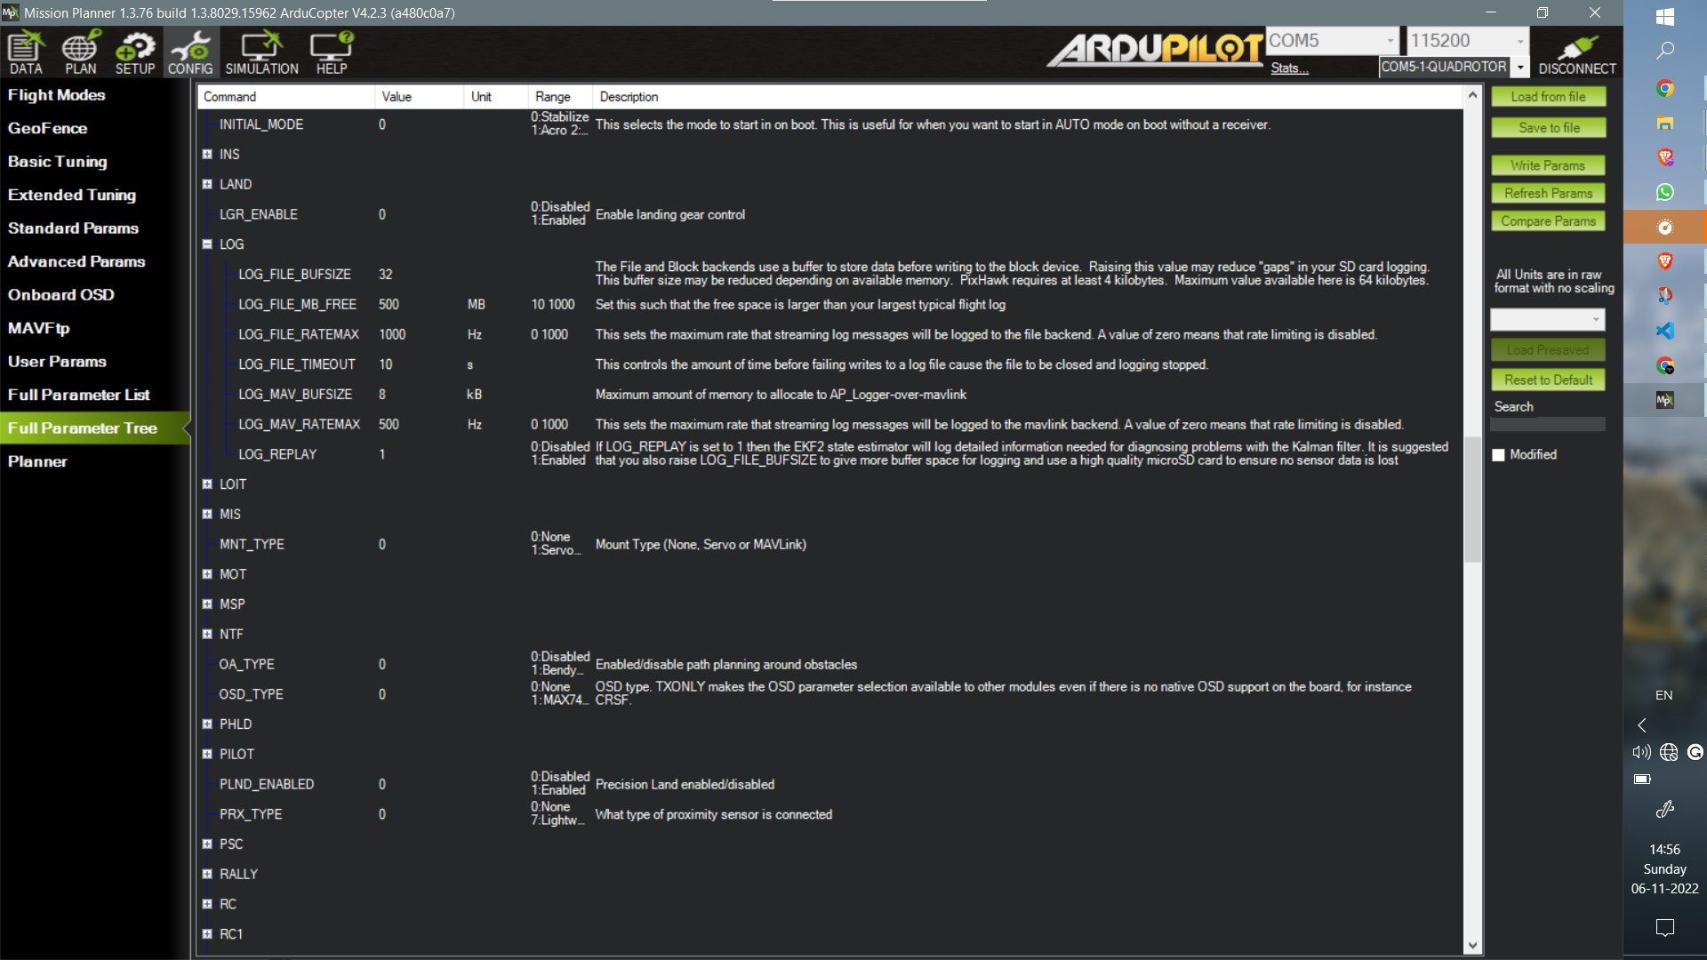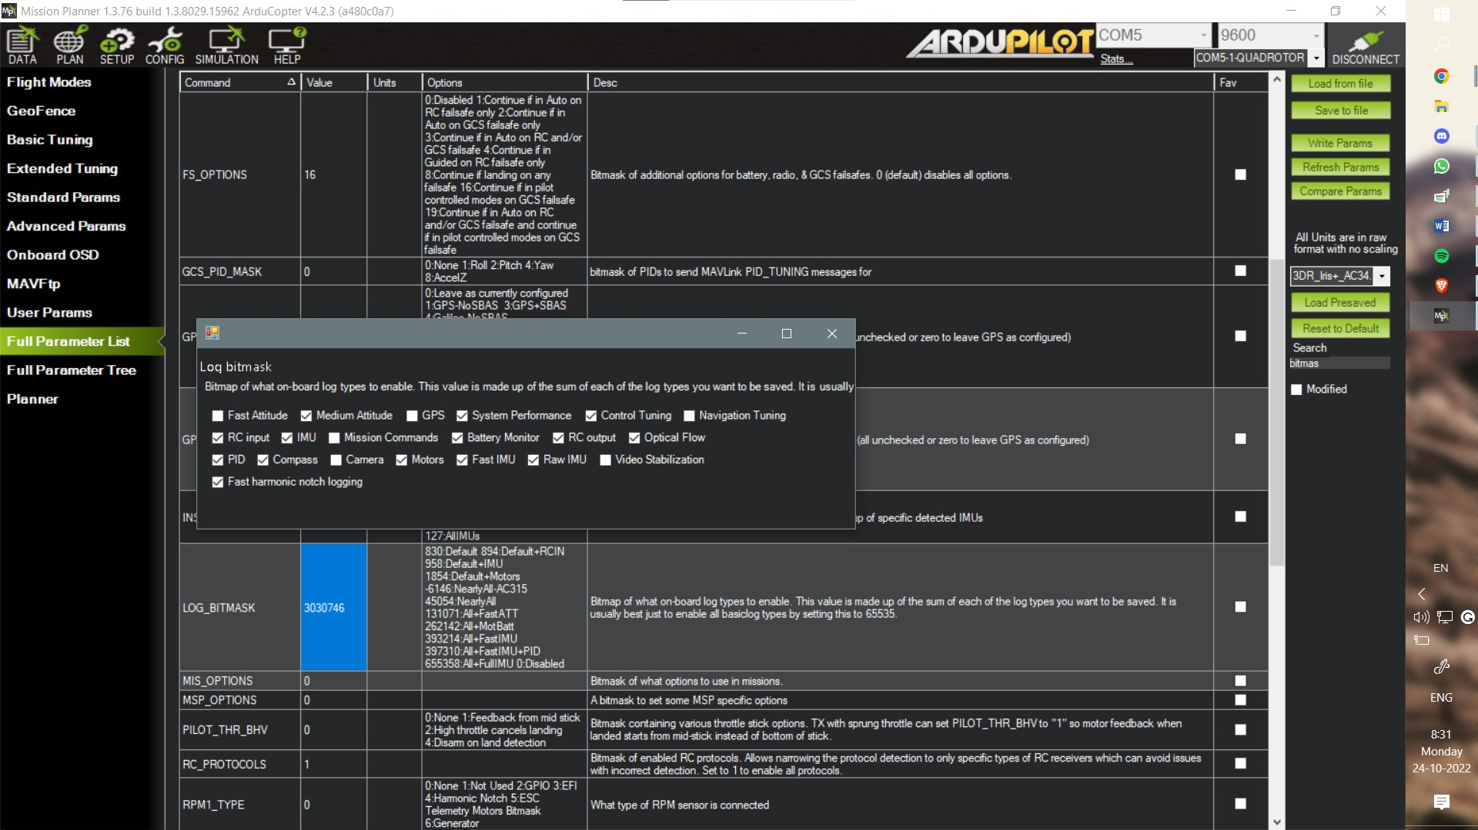

### ArmCheck

These are set of preflight precautionary checks in order to avoid malfunctioning of any system during the course of flight.

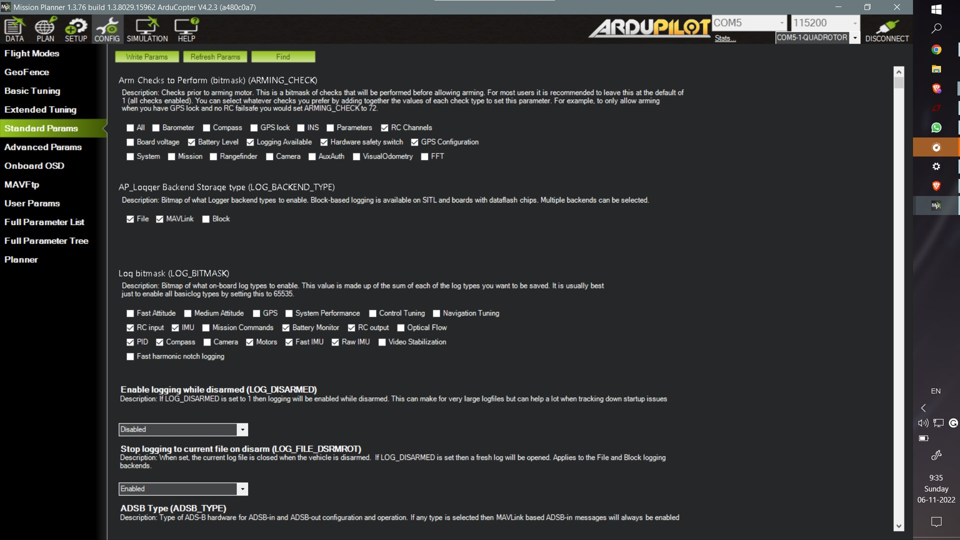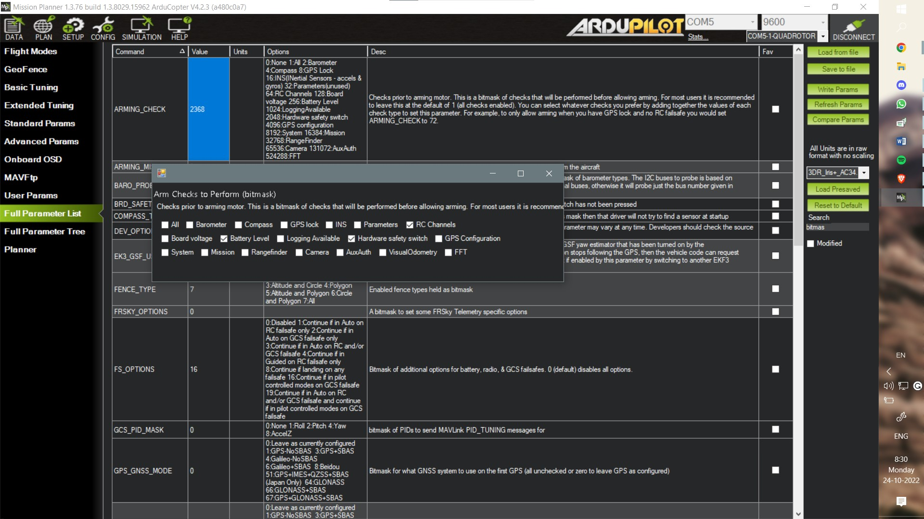

## Conclusion

The work done till the MidSemester Exams include the assembly of the drone, and flying it. Apart from that,there were learnings about different parameters done which were stopping the drone from arming.The parameters that involves the Preflight tests before arming was changed in order to make it fly with few of the components not working.Mission Planning, making a geofence inclusion polygon along with exclusion circles were some of the other learnings.  
The work ahead of us is the use of Raspberry Pi to stream telemetry data to the ground station and then later use mission planning to make the drone follow a predecided trajectory.

## Bibliography

* [F450 Frame](https://robu.in/product/q450-quadcopter-framepcb-version-with-integrated-pcb-plastic-landing-gear-combo-kit-2/?gclid=CjwKCAjwtp2bBhAGEiwAOZZTuPNvjoUGYYbtOJGQNqHWazTdY3pi9mIC1HxRZmbPHcXwtGxjorTOohoCpR8QAvD_BwE)
* [GPS Unit](https://robu.in/product/ublox-neo-7m-gps-compass/?gclid=CjwKCAjwtp2bBhAGEiwAOZZTuDt-fR5tCmkfJER-Cx4NJr68WiY3Lm5CrC7bUD2fJmbm1zXCGnWPDhoCAeIQAvD_BwE)
* [Pixhawk](https://robu.in/product/pixhawk-radiolink/)
* robu.in
* [LEDs Meaning — Copter documentation - ArduPilot](https://ardupilot.org/copter/docs/common-leds-pixhawk.html)
* [Safety Switch — Copter documentation - ArduPilot](https://ardupilot.org/copter/docs/common-safety-switch-pixhawk.html)
* [Buzzer (aka Tone Alarm) — Copter documentation - ArduPilot](https://ardupilot.org/copter/docs/common-buzzer.html)
* [github.com/sakshamssy/quadcopter_navigation](https://github.com/sakshamssy/quadcopter_navigation)